Purpose
We would like to write a prediction model to detect transdifferantiation within the macrophages into PDGFRb+ macrophages and towards mural cells.
To be considered:
- Macrophages are “Macrophages” in “cell_type”
- PDGFRb+ macrophages are “2” in “cluster” and “cluster_ct”
- Mural cells are “Mural cells” in “cell_type” and “cluster_ct” or “8” in “cluster”
- In the paper https://www.nature.com/articles/s44161-024-00478-0, you find the analysis of day 21 and healthy samples and in Figure 3e there is the pseudotime based on day 21 of this population.
- PDGFRb+ macrophages/“2” are highly expressed at day 21, but there are really few in healthy, day 7 and day 14 (Figure A below, cluster 2/orange line).
- PDGFRb+ macrophages/“2” macrophages are characterized by highly unspliced mRNA compare to other macrophages, sign of changing in transcription and therefore sign of transdifferentiation (Figure 3e in the paper).
- PDGFRb+ macrophages/“2” macrophages at the different time point have different proportion of unspliced/spliced mRNA (figure b below). This could be also a useful parameter to considering in writing the prediction model.
- When I run the pseudotime analysis in ss2 or in the ss2+ss3 datasets, the psudotime is similar towards Mural cells or FAPs.
Figure A
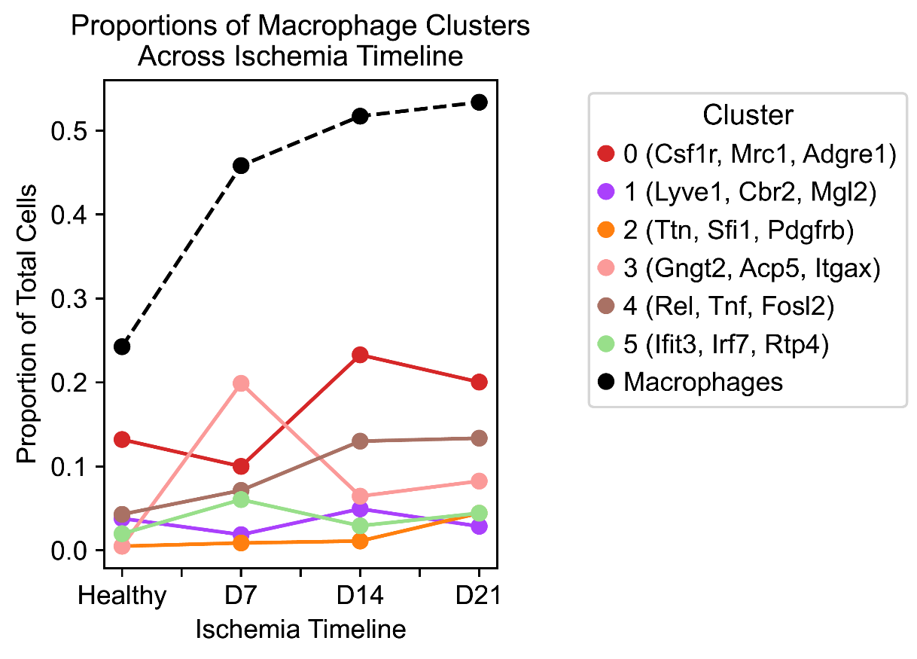

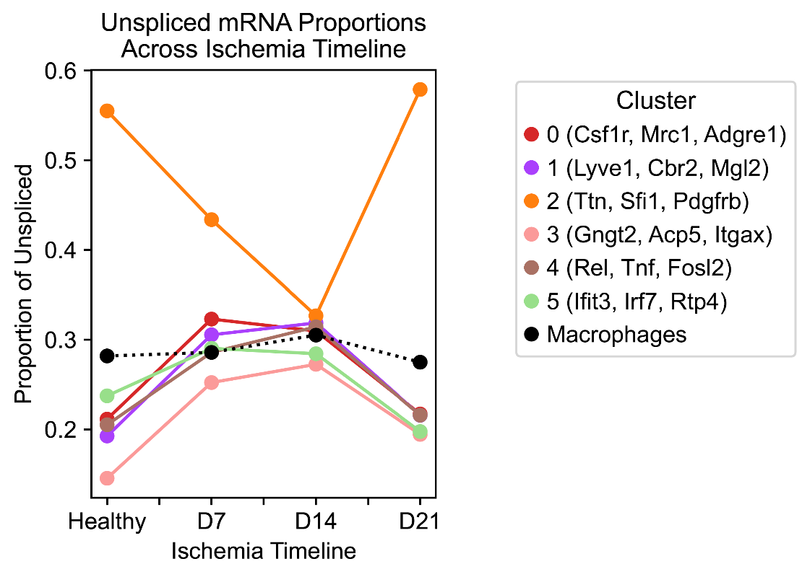
Figure B

H5ad folder:
The final data are in adata_final.h5ad. This file is the combination of 2 different setsof single cell sequencing: ss2 and ss3.
And you find all the various h5ad files there.
NOTE: ss2 has only day 21 and healthy sample while ss3 has day 7, day 14, day 21 (really few) and healthy.

Scripts folder:
In this folder you find the python scripts used to process the data and binding them together.
- SS2:
data.process is the processing of the data.
While data_analysis are the analysis that are published in the paper: https://www.nature.com/articles/s44161-024-00478-0
- SS3
“2025_Integration_of_SS2_and_SS3_v1” is the integration that will create the adata_final.h5ad.
“2025_Scanpy_from_counts_matrix_to_adata_SS3” is the processing of ss3 data for integration with ss2
Top25 genes in group 2 (PDGFRb+ macrophages are “2” in “cluster” and “cluster_ct”)

Ttn
Sfi1
Duxf3
AW822073
Fau-ps2
Neb
Gapdh
Ilk
Ppp1ca
Tpt1
Rac1
Aldh2
Cfl1
Ubb
Tmem50a
Anxa5
Taf10
Rps3
App
Rpl13
Eif4h
Atp5c1
Pdia3
Eef1a1
Hsp90b1

Top25 genes in group 8 (Mural cells are “Mural cells” in “cell_type” and “cluster_ct” or “8” in “cluster”)

Notch3
Gucy1a1
Itga7
Myl9
Pdgfrb
Cald1
Cpe
Mylk
Myh11
Rbpms
Tinagl1
Epas1
Mcam
Ndufa4l2
Tpm1
Rasl12
Atp1b2
Ano1
Gucy1b1
Rgs5
Tpm2
Pde3a
Mfge8
Dlc1
Acta2

